https://kb.objectrocket.com/postgresql/python-error-handling-with-the-psycopg2-postgresql-adapter-645
https://www.tutorialspoint.com/python_data_access/python_postgresql_database_connection.htm#:~:text=Establishing%20connection%20using%20python,and%20returns%20a%20connection%20object.
>>> conn=psycopg2.connect(database="mydb", user="postgres", password="123",port=5432)

conn=psycopg2.connect(
database="mydb",
user="postgres",
host="/tmp/",
password="123"
)

DATABASES = {
'default': {
'ENGINE': 'django.db.backends.postgresql_psycopg2',
'NAME': 'test',
'HOST': '127.0.0.1',
'USER': 'postgres',
'PORT': '5432',
'PASSWORD': '1234'
}

Change django.db.backends.postgresql_psycopg2 to django.db.backends.postgresql.
>>> import psycopg2
>>> c = psycopg2.connect("host='localhost' dbname='mydb' user='myuser' password='secret'")

DATABASES = {
'default': {
'ENGINE': 'django.db.backends.postgresql',
'NAME': 'mydb',
'USER': 'myuser',
'PASSWORD': 'secret',
'HOST': 'localhost',
'PORT': '5432',
'OPTIONS': {'sslmode':'disable'},
}
}

Define the ‘print_psycopg2_exception()’ Python function
Use Python’s def keyword to define a new function and make it accept a TypeError Python object class as its only parameter:
1  2 | # define a function that handles and parses psycopg2 exceptions  def print_psycopg2_exception(err):

Use Python’s built-in ‘sys’ library to get more detailed exception information
The next bit of code grabs the traceback information for the exception, including the line number in the code that the error occurred on, by calling the sys library’s exc_info() method:
1  2  3  4  5 | # get details about the exception  err_type, err_obj, traceback = sys.exc_info()  # get the line number when exception occured  line_num = traceback.tb_lineno

Print the details for the psycopg2 exception
Use Python’s print() function to print the details of the psycopg2 exception that was passed to the function call:
1  2  3  4  5  6  7  8  9  10 | # print the connect() error  print ("\npsycopg2 ERROR:", err, "on line number:", line_num)  print ("psycopg2 traceback:", traceback, "-- type:", err_type)  # psycopg2 extensions.Diagnostics object attribute  print ("\nextensions.Diagnostics:", err.diag)  # print the pgcode and pgerror exceptions  print ("pgerror:", err.pgerror)  print ("pgcode:", err.pgcode, "\n")

Handle psycopg2 exceptions that occur while connecting to PostgreSQL
en defined it’s time to test it out by running some psycopg2 code. The following Python code attempts to make a connection to PostgreSQL in a try-except indentation block, and, in the case of an exception, passes the TypeError Python object to the print_psycopg2_exception() function defined earlier:
1  2  3  4  5  6  7  8  9  10  11  12  13  14 | # declare a new PostgreSQL connection object  try:  conn = connect(  dbname = "python_test",  user = "WRONG_USER",  host = "localhost",  password = "mypass"  )  except OperationalError as err:  # pass exception to function  print_psycopg2_exception(err)  # set the connection to 'None' in case of error  conn = None
NOTE: The above code will give the connection object a value of None in the case of an exception.
If the username string, passed to the user parameter, doesn’t match any of the users for the PostgreSQL server then the function should print something that closely resembles the following:
1  2  3  4  5  6  7  8 | psycopg2 ERROR: FATAL: password authentication failed for user "WRONG_USER"  FATAL: password authentication failed for user "WRONG_USER"  on line number: 43  psycopg2 traceback: <traceback object at 0x7fa361660a88> -- type: <class 'psycopg2.OperationalError'>  extensions.Diagnostics: <psycopg2.extensions.Diagnostics object at 0x7fa3646e1558>  pgerror: None  pgcode: None

Handle psycopg2 exceptions that occur while executing SQL statements
If the code to connect to PostgreSQL didn’t have any problems, and no exceptions were raised, then test out the function again. The following code purposely attempts to use a cursor object to execute() a SQL statement with bad syntax:

1  2  3  4  5  6  7  8  9  10  11  12  13  14  15  16 | # if the connection was successful  if conn != None:  # declare a cursor object from the connection  cursor = conn.cursor()  print ("cursor object:", cursor, "\n")  # catch exception for invalid SQL statement  try:  cursor.execute("INVALID SQL STATEMENT")  except Exception as err:  # pass exception to function  print_psycopg2_exception(err)  # rollback the previous transaction before starting another  conn.rollback()
The print_psycopg2_exception() function should print a response that resembles the following:
1  2  3  4  5  6  7  8  9  10  11  12 | psycopg2 ERROR: syntax error at or near "INVALID"  LINE 1: INVALID SQL STATEMENT  ^  on line number: 90  psycopg2 traceback: <traceback object at 0x7f58dd244188> -- type: <class 'psycopg2.errors.SyntaxError'>  extensions.Diagnostics: <psycopg2.extensions.Diagnostics object at 0x7f58e0018558>  pgerror: ERROR: syntax error at or near "INVALID"  LINE 1: INVALID SQL STATEMENT  ^  pgcode: 42601
The 42601 PostgreSQL code indicates that the exception resulted from a syntax error in the SQL statement:
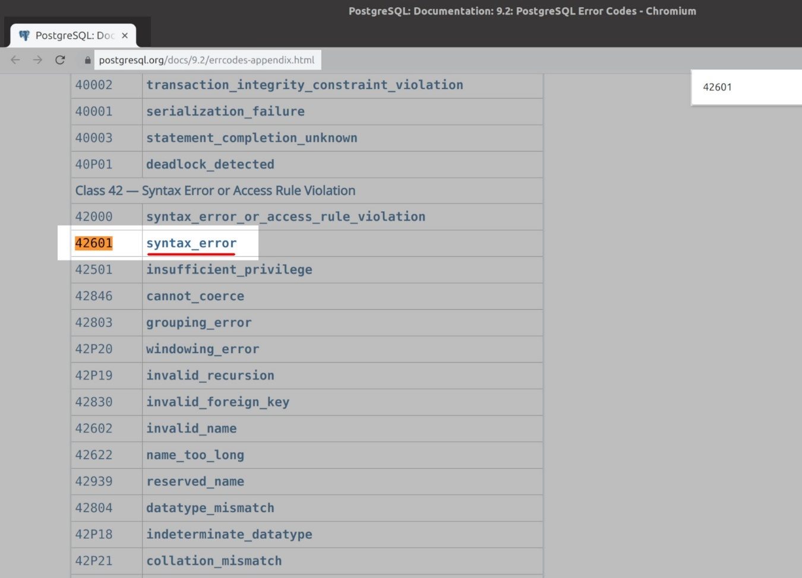

1
El comando es
python manage.py makemigrations
y no olvides tener activo el virtual Si es la primera vez que corres las migraciones, antes de ejecutar makemigrations ejecuta el comando:
python manage.py migrate

